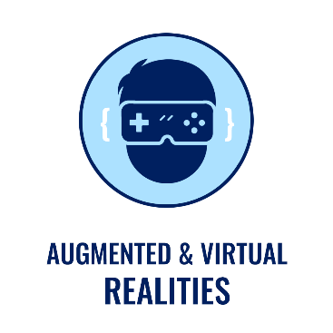Individual Assignment 1a:   
Proposal of WebXR Application

Sky Billiard

05111740000196- Jihad Rausyan Fiqrussalam

## Application Overview

Sky Billiard is simple billiard video game based on A-FRAME, Web Framework for making VR Application. In this game, player will be given a white ball for shooting another ball into six holes that spreads in the billiard table, four on each corner and two on the long sides. If the white ball suddenly goes into those holes, player can retrieve it with pressing the button that available on the short side of billiard table. The game is finish when the player makes those ball, excluding the white ball, goes into holes.

## Sketch of XR World

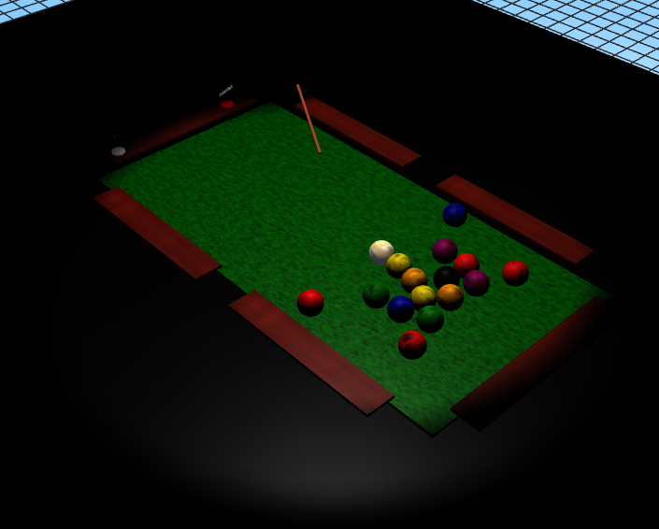

Figure 1. Billiard tables and the player ( billiard stick )

## Sketch of Interaction

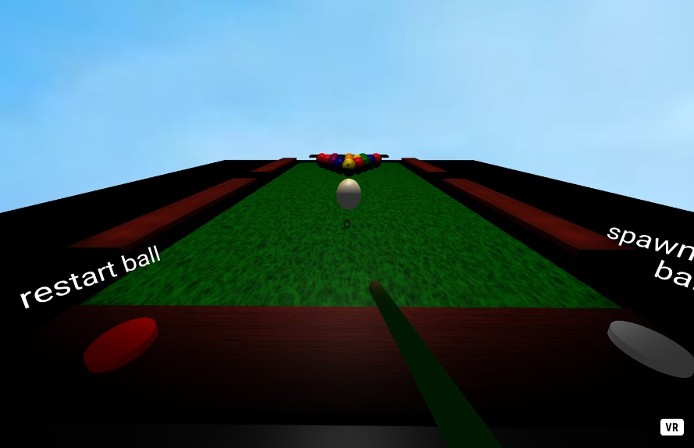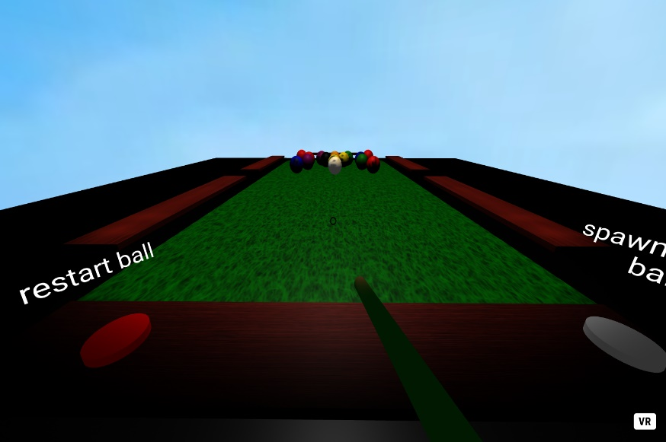Figure 6. Player Shoots the white ball with Left Mouse Button

*Figure 7. Balls collides with each other*

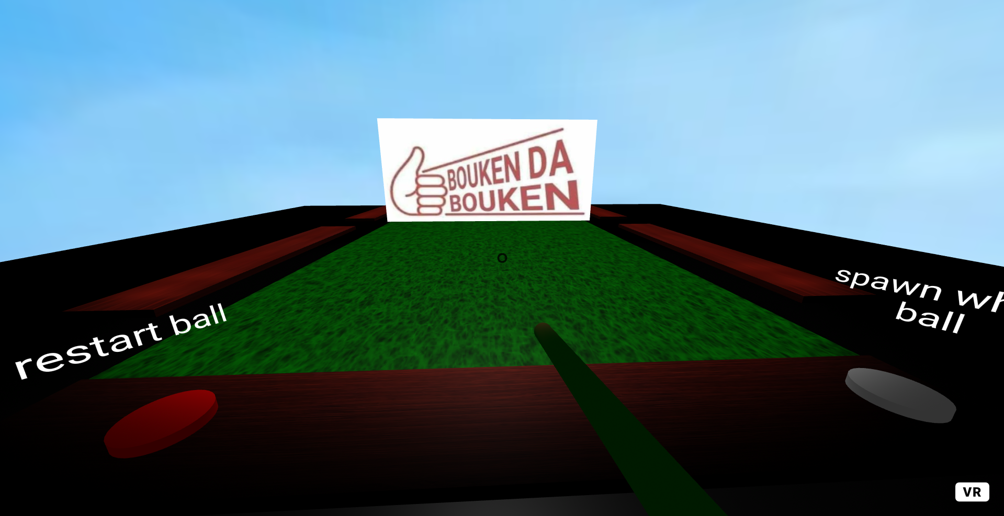

*Figure 8. Player wins the game after makes the 15 balls goes to holes*

## Object Dynamics

### Local Variables

White Billiard Ball

* User can shoot
* User can spawn it with the “spawn white ball” button if it went to hole, repeatedly

Billiard Balls

* The Billiard Balls can collide with each other, including the white one
* User can ‘t shoot it, but can use the white one to make them went to hole
* User win the game if all of 15 balls went to hole

### External Variables

MySQL

* Submit the name and time spent